Proposal

Grainger
Salesforce Void Management

Version 1.0
April 4, 2023
Contents
1 Executive Summary 3
1.1 Introduction 3
1.2 The Business Opportunity 3
1.3 The Project 3
1.4 The Business Benefit 3
1.5 The Timeframe 4
1.6 The Cost - Overview 4
1.7 The Relationship 5
2 Proposed Solution 6
2.1 Future Functionality 7
2.2 Sample Screens 7
2.3 Solution Context 8
2.4 Technical Overview 9
2.5 Implementation Approach 11
2.6 Training 11
2.7 Support 11
2.8 Exclusions and Limitations 11
2.9 Assumptions 13
2.10 Prerequisites 14
3 Detailed Costs 16
3.1 Dependencies 19
3.2 Change Management 19
4 Project Methodology & Experience 21
4.1 Project Methodology & Approach 21
4.2 Project Team 22
5 Next Steps 23
6 Acceptance 24
7 Addendum / Appendices 25

Executive Summary

Introduction
<Context of proposal>
This proposal has been prepared at the request of Client Name and outlines the development of xyz.

The Business Opportunity
<Summary of business opportunity that is available. Rephrase negative problems as positive opportunities.>
<Web app example>
Users of JLL’s Inspection Tool often need to create various reports to provide their clients with information relating to specific inspections or groups of inspections. JLL have identified that their property inspectors spend a lot of time copying data from the simple reports that the Inspection Tool currently generates, into customised reports suitable for their clients’ needs.
In order to reduce wasted time and increase efficiency, JLL seeks to make report generation easier, allowing inspectors to quickly generate standardised, client-facing reports while reducing errors incurred during a manual copying process. A central repository would also allow better report traceability and easy access to historical reports.

The Project
<Summary of the proposed project>
Open Box Software has been approached to develop a point of sale, web ordering and simple inventory system which will provide the capacity for future enhancements as the business grows.
It is proposed that the delivery of the solution will be completed in a phased approach. Phase one will include: Point of Sale (POS) terminal application, kitchen terminal application, POS reporting and administration. Phase two will include: Integrated Website, web pickup terminal application, reports for inventory and reports for web sales.

The Business Benefit
<Business value and benefits that the project will provide. These are the criteria against which the project’s success will be measured (i.e. key success factors). Try to identify measurable benefits such as client benchmarks where possible.>
- <E.g. improved efficiency / time savings / reduced resources / faster turnaround; reduced cost / financial savings; reduction in errors; lower risk; improved security; mobility / accessibility; greater data integrity / data quality; improved user experience; legal compliance; improved competitive advantage / product marketability; improved management visibility / transparency / traceability; leverage existing data / functionality; reduce dependency on third party; standardizing processes; greater control>
The solution has the potential to enhance the business value that the MRI Residential Management product suite provides to MRI Software, as well as its customers, with:
- Improved user experience
- Reduction in time and effort in converting leads to leases
- Improved data integrity with automated updates to MRI

The Timeframe
The expected timeframe for delivery of the project is as follows:
- Design: x weeks from requirements sign-off
- Development & Testing: x months from design sign-off
- UAT: x weeks
- Go-Live: [Month YYYY] (assuming project approval by [date])
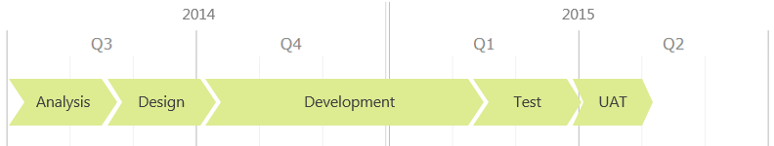
This proposal is valid for [thirty (30) days].

The Cost - Overview
The cost of the proposed project is estimated to be $x to $y/Rx to Ry excluding any sales taxes (GST / VAT), if applicable.
Further details may be found within the Detailed Costs section.

The Relationship
Open Box will assign a dedicated Grainger account manager who will be responsible for managing the long-term relationship and building a Grainger knowledge-base which may be applied to future projects. The manager will also bring with a solid foundation of experience working with other real estate companies.

Proposed Solution
<Detail the proposed solution. Establish the scope of the project, major objectives to be addressed, key features and deliverables.>
<Reference latest documentation if completed, if any. Otherwise this section should be very detailed>
[The following should be read in conjunction with the [latest documentation] document dated [date] delivered to Client.]
Open Box proposes to deliver an online leasing module – Prospect Connect – that will be available as an optional module to MRI Residential Management SaaS customers.
Prospect Connect will provide a residential lease application process which generates a lease agreement that is e-signed by the prospective tenant. The module will integrate seamlessly with MRI SaaS.
The solution will address the following objectives:
- Online Registration - A prospective tenant enters their personal information, accepts terms and conditions and receives a welcome email.
- Selection of Lease Options – The prospect selects lease options including lease term and occupancy date.
- Applicant Information – Information about all the applicants as well as any pets is entered. Applicants include co-tenants, occupants and guarantors.
- Online Payment – Payment of the application fee is authorized using a credit card.
  - Where authorization is successful, the apartment is temporarily reserved for the applicant.
  - Reservations are automatically cancelled if the online application is subsequently abandoned.
- E–signing – Prospects would be able to e-sign the generated lease agreement.
- MRI Integration – Property, apartment, rent and fee data is sourced from MRI Residential Management (RM). MRI RM data is updated at key points in the workflow by:
  - Creating guest cards for all applicants and updating these with any resident screening outcome.
  - Creating prospect actions (such as internet visit, background check, application denied).
  - Creating lease applications
  - Creating a leasing summary of rent charges.
  - Creating/cancelling permanent and temporary apartment reservations.
  - Uploading a report of resident screening results.

Future Functionality
Additional functionality that is not included in the initial project scope as outlined above, but which may be addressed in future project releases includes:
- Garage / Parking Bay void
- FSI integration

Sample Screens
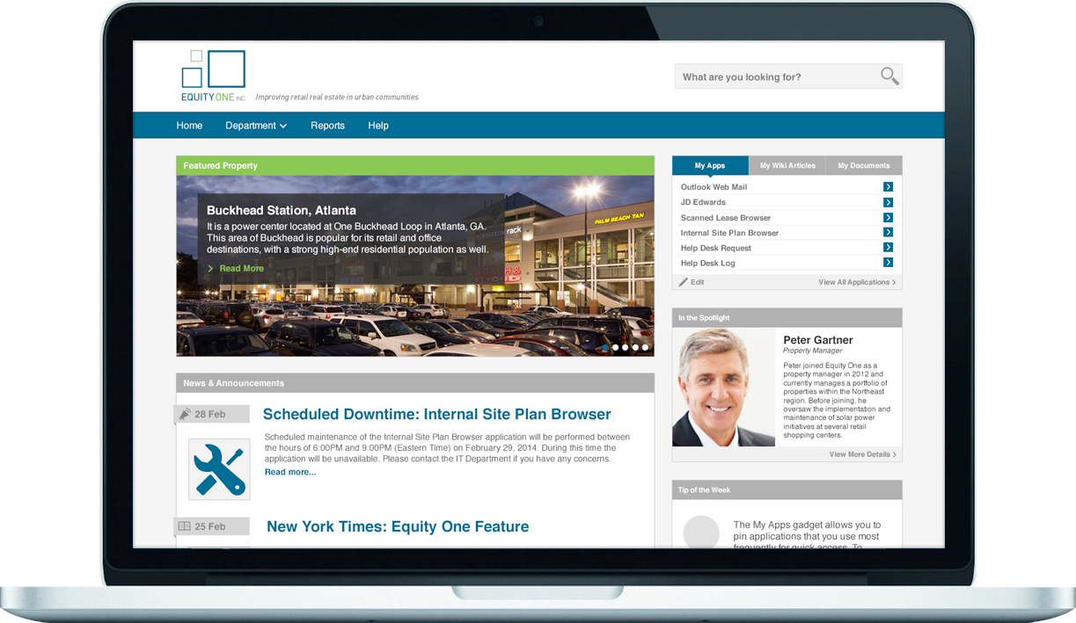
Figure 1: Sample Screen – Description

Solution Context
The following provides an overview of the solution’s interfaces:
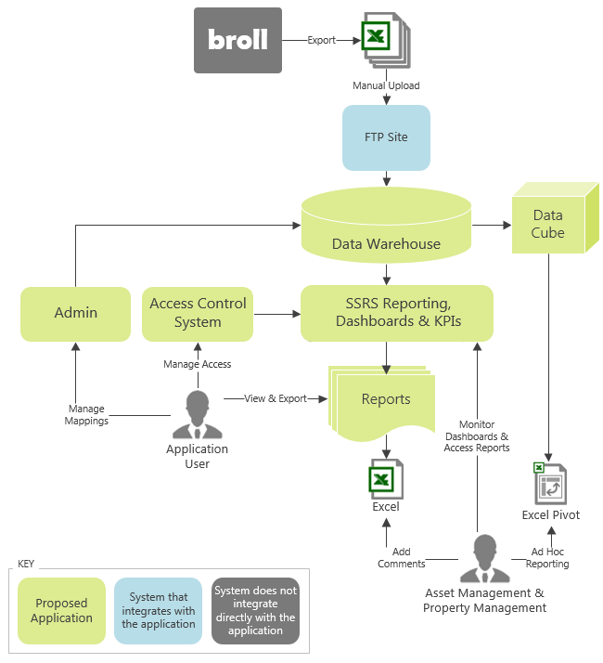
Figure 6: Proposed Solution Context
- Key Element in Context Diagram – Detail
- Prospect Connect
  - The solution will be deployed within the MRI SaaS environment.
    - Prospect Connect will integrate with the MRI database via direct SQL updates, however an integration layer will provide the foundation for integration with other ERPs in future releases.
  - The application will comply with Multifamily Information and Transactions Standards (MITS) where applicable.
- DocuSign
  - Electronic signature functionality will be provided through DocuSign or an alternative third-party service provider.
  - Integration will take place via APIs.

Technical Overview
<Where appropriate, include high-level points on the technical solution that will be built – what technologies used and what it will run on (applications, systems, OS etc.). Ensure that it is fluid enough to give options when we get to the design stage, but scope out complex technologies e.g. run on IE 6.0 on XP not IE 6.0 on PDA etc.>
<High-level components e.g. mobile platform, web platform, web API, business layer, database, access control system>
<Third party tools e.g. augmented reality, CAD, PDF annotation, handwriting recognition>
<Security overview>
<Hosting requirements e.g. server environments, networking requirements>
<Backup and recovery>
The proposed inspection tool will consist of native iOS and Android mobile apps and a companion web-based interface which share a common back-end. The mobile apps will synchronize data with the back-end via a web API. The web components and database back-end will be built and hosted on the Microsoft technology stack.
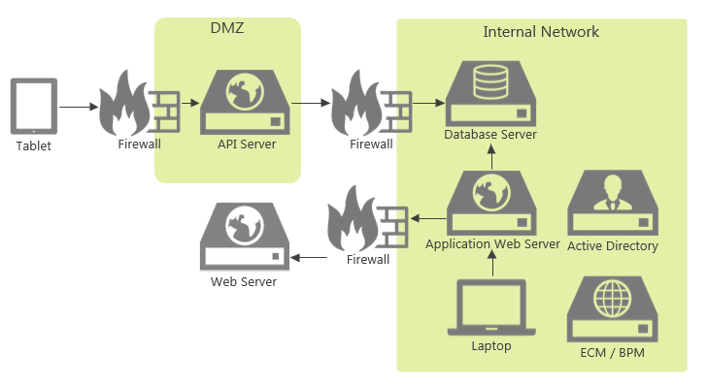
Figure 7: Proposed Infrastructure Diagram
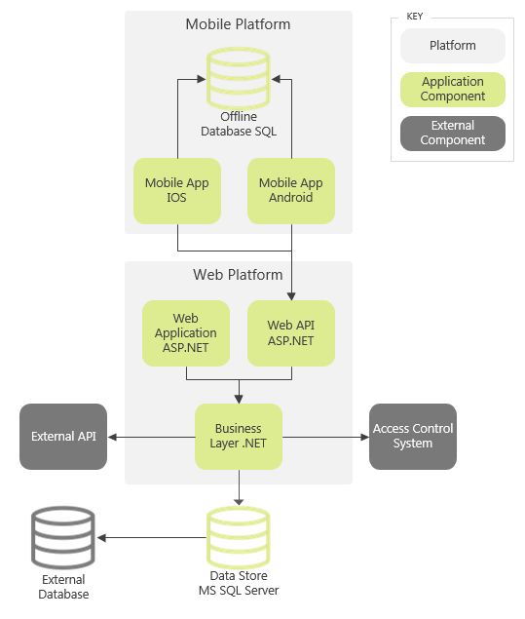
Figure 8: Proposed Architecture Diagram

Implementation Approach
<Discuss any proposed phasing where applicable>

Training
To facilitate the training process, Open Box will train a designated Client Name representative. / Open Box will not be required to do end user training or develop any training materials. /End user training and the development of training materials will be the responsibility of Client Name. Open Box will provide [16 hours] of technical consultation time to assist Client Name with this process. / Open Box will deliver a training manual detailing the high level functionality of the solution to assist the end user when using the solution.
[Where Client Name plans to perform further in-depth training to increase user adoption and requires additional training consultation time from Open Box, this effort will be billed on a time and materials basis.]

Support
Open Box Software will provide [40 hours] of offsite, weekday support within the [first month] after the application goes live. / The project cost does not include ongoing support and maintenance of the solution.
Additional support may be made available through a separate support and maintenance contract, should this be deemed necessary. Open Box has a number of support models available.

Exclusions and Limitations
In order to right-size the proposed project, certain functionality will be excluded. The following is not included in the cost or scope of this project:
- The following functionality will not be included in the initial project, but may be addressed in subsequent releases:
  - <Nice-to-have functionality>
- <Exclusions and limitations of proposed project>
- The user interface will not support multiple languages.
- The ability to create or maintain report templates is beyond the scope of this proposal.
- The web application will not be developed with a responsive user interface for use on mobile devices.
<DW & Reporting Examples>
- No extraction of data from sources other than [MRI, ARGUS Valuation DCF, Chatham Financial and the two Excel workbooks].
- No modifications to the SSRS report generation user interface. This will be the standard Reporting Services web portal as included with the SSRS installation.
- Report users will not be able to add or customize the SSRS reports, other than to filter and format the report output based on pre-defined parameters and display options.
- No customizable, ad hoc reporting including MS Power Pivot and MS Power View.
- No support for multi-currency or currency conversion.
  - All data in the data warehouse will be stored in US Dollars.
<Mobile examples>
- No application will be provided for users with Blackberry devices.
- The mobile application may not be fully compatible with future mobile operating system updates and changes may be required due to unforeseen operating system changes.
<Website examples>
- The application will be tested against the following browsers only:
  - Edge v38+
  - Chrome v50+
  - Opera 39+
  - Morzilla Firefox v57+
  - Safari OS X 9.1.2+
  - Safari for Windows 5.1.7+
- All versions of Internet Explorer will not be supported; the website may therefore not displayed correctly.
- The website administration/content management screens may not be fully responsive (for example may not be accessible on mobile devices).
- The website would not integrate with any applications other than the content management system, hyperlinks to other websites and embedded, third party widgets.
- Online applications would not include electronic signatures. Applicants might - for example - enter their name, social security number, date, check a box agreeing to terms and conditions and click a button to ‘Sign and Submit’ the application.
- The selection of content management system could impact the website design and the ability for the site to be responsive.

Assumptions
The following assumptions have been made; incorrect assumptions may affect project cost and timelines.
- <Assumptions regarding project nature and scope>
- Client Reports to be made available in Word and Excel format.
- The chosen reporting platform must be compatible with Azure cloud-based services.
- No data migration is required as part of the project.
- The system will integrate with Client Name’s Active Directory.
- The system will be designed and optimised for use with [Chrome].
- Standard buttons will be used, dependent on the third-party dashboard tool selected.
- There will be no separate [mobile/desktop] application.
Project Management
- Open Box resources will be contactable and available for meetings via conference calls/video conferences:
  - Monday to Friday 9am – 6pm South African time (GMT+02:00), excluding public holidays.
- A defined escalation path will be provided to the agreed Client Name project manager should urgent assistance be required outside of these times.
<DW & Reporting Examples>
- All data required to be included in the reports generated by this solution:
  - Will be provided by the source data, or
  - Can be calculated from the source data.
- The [two] Excel workbooks containing source data are each assumed to:
  - Be in [XLSX/XLXB] format.
  - Contain a maximum of [10] sheets of data to be imported.
- The Excel workbooks will adhere to the format required by the Data Warehouse ETL (Extract, Transform and Load) process.
- The file drop location will be in the same network as the proposed solution.
- The MRI instance is assumed to be SaaS hosted and have the MIX API license activated.
- All required source data from [ARGUS Enterprise/Chatham Financial/other ERP] is assumed to be accessible via API.
- A complete and comprehensive specification detailing [ARGUS Valuation DCF]’s data structures and associated information will be available.
- [Ten] core database tables from [ARGUS Valuation DCF] will be sourced via direct database integration.
- Reports will source data directly from the data warehouse.
- Reports will be generated ad hoc by reporting users. Open Box will not create any report schedules as part of the project.
- Data exports for ad hoc analysis via Excel will be made available through SQL Server database views applied to the data warehouse.
<Website examples>
- Standard Google analytics to be integrated without any customizations required.
- Client Name will be responsible for providing the website content including text, images, logo, documents and hyperlinks.

Prerequisites
To enable Open Box to deliver the items above, Client Name will need to deliver the following in a timely manner. / Before commencing [the project], Client Name will need to supply the following:
- <List project and technology dependencies>
- Should Client Name have specific project management requirements for the project, these should be identified and agreed upon with Open Box prior to project commencement.
- Remote access to all servers and terminals that will use the system.
- Access to relevant development and UAT environments.
<DW & Reporting Examples>
- Access to the source systems and data which will be required for analysis purposes:
  - [MRI
  - ARGUS Valuation DCF
  - Chatham Financial
  - Excel Workbooks for Amortization of Intangibles and Capital Expenditures]
- Access to the Excel workbooks pick-up location.
- All relevant Client Name IT policies, particularly with regard to data security standards and requirements.
- All relevant audit assurance requirements, particularly with regard to data migration and interface requirements.
- Latest version of the example reports pack.

Detailed Costs
<Fixed Cost>
The phases and resource requirements for this project are envisioned to be as follows:
Phase | Effort (Days) | Duration (Days)
Project Management & Administration | x - y
Analysis & Design | x - y | x - y
Project Definition & Scope | x - y
Requirements Gathering | x - y
Solution Design | x - y
Graphic Design | x - y
Build | x - y | x - y
Development | x - y
Internal Testing | x - y
Client Demonstrations | x - y
Implementation & User Acceptance | x - y | x - y
Deployments | x - y
User Acceptance Testing Assistance & Updates | x - y
User Training & Support Documentation | x - y
Post Go Live Support | x - y
Total | x – y [Cost] | x – y [ Duration]
The estimated cost for the proposed project is $x to $y/Rx to Ry, excluding sales tax, if a [20%] allowance for unidentified requirements is applied.
This includes [x weeks] of UAT, supported by [1] project resource. Any UAT extensions will [incur additional costs/be billed on a time and materials basis].
Costs will be billed as follows:
- Analysis to be billed on a time and materials basis.
- Remaining project cost (to be finalized on completion of functional specification):
  - 25% – Billed on sign-off of the Functional Specification.
  - 50% – Billed on delivery to Client’s test environment for UAT.
  - 25% – Billed on live deployment or [1 month] after delivery to Client’s test environment, whichever comes first.
<T&M>
This project will be billed monthly, on a time and materials basis at a rate of $x per hour/ Rx per hour, excluding sales tax.
It is expected that the project duration will be approximately x to y days/weeks of effort if a x% allowance for unidentified requirements is applied. Thus the total cost of the project is estimated to be $x to $y/Rx to Ry, excluding sales tax.
Cost will be reported to Client Name on a [weekly basis/in the weekly project management report] during the course of the project. [The cost will not exceed the upper limit of $z/Ry without prior consultation.]
<FTE>
The project will be billed monthly, on an FTE basis.
- “FTE” is defined as 160 hours per month.
- One FTE may be made up of more than one Open Box member of staff through the duration of each month.
- Unused time will not automatically roll over into the following month.
The project is expected should consume x to y full time equivalent (FTE) resources over a duration of x to y weeks if a x% allowance for unidentified requirements is applied. The total estimated cost is $x to $y/Rx to Ry, excluding sales tax.
[By the [15th] of each month, Open Box will deliver to Client Name a forecast of the required FTEs for the following month.
- By the [20th] of each month Open Box and Client Name will agree on the number of FTEs to be allocated for the following month.
- This agreement will be binding on both parties for the following month and will be invoiced by Open Box at the end of the following month.
OR: The agreement will be automatically renewed on a monthly basis, with one prior month’s notice to be given, by either party, of the intention not to renew.
- Client Name should communicate any requests for additional FTEs by the [15th] of the month, to be made available at the beginning of the following calendar month.
  - Open Box will make every effort to provide additional resources where requested, however this will be subject to resource availability.
- Client Name will provide [one prior month’s] notice of the intention to reduce the number of FTEs required.
- Costs will be billed monthly, in arrears. ]
<All Projects>
Open Box will endeavor to commence work within [2 weeks] of receiving sign-off, contingent on operational factors.
The cost includes:
- Requirements analysis and design
- [Graphic design]
- Development
- Testing [and automated tests]
- [Documentation]
- Deployment to Client Name’s staging and live environments
- [40 hours] post-implementation support
The above cost does not include:
- Any third-party costs, license fees, subscriptions or services
- Hardware and infrastructure
- Support and maintenance
- Travel and subsistence
  - Should onsite personnel be required, any related expenses will be reimbursed by Client Name. Client Name shall be notified prior to, and give approval for, any expenses being incurred. [A cap of 10% of the value of the project shall not be exceeded for additional project expenditure that falls into this category.] [These expenses will be payable on invoice throughout the project.]
- Additional exclusions as agreed upon in the User Requirements Definition or Functional Specification documents and their amendments

Dependencies
<Fixed Cost> Final cost and timeline will be delivered on Client Name sign-off of the Functional Specification.
<FTE & T&M> A final estimate of cost and timeline will be delivered on completion of the Functional Specification phase of the analysis.
Regular updates regarding any significant changes in scope or cost will be delivered to Client Name as and when they occur.
Costs and timelines are contingent on:
- <List non-functional assumptions regarding costing & duration. Do not repeat functional assumptions from above.>
- Prompt review, feedback and sign-off of project documentation by Client Name.
- [Client Name delivering the required new website content (text, images, PDF documents, etc.) in a timely manner.]
- Client Name is responsible for the configuration and stability of the UAT/staging and live environments (hardware, operating system and supporting applications).
- Completion of UAT by Client Name within a [x-week] timeframe. UAT will be assumed to be complete if no feedback has been received within [15 days] of the deployment to the test environment.
- Client Name making the necessary resources available, as and when required, ensuring no delays occur through the various phases. Timing commitments cannot be guaranteed by Open Box if resources are not made available to the project.
- There are no other projects planned or in operation that may hinder this project.

Change Management
Should any of the assumptions, exclusions or dependencies as agreed upon during the duration of the project change in any way that might affect the project timeframe and costing, Open Box reserves the right to renegotiate the cost of the project via the Change Management process.
Additionally, any requests for additional work, beyond the agreed scope of the project and the agreed design will be managed via a change control process. Such changes may incur additional cost and may affect the project timelines.
Change requests shall be brought before the Client Name and Open Box project managers for discussion and decision on whether the change should be included as part of the implementation. Any changes that require additional resources or time for the project will require approval by the Client Name project manager prior to work commencing on the change.

Project Methodology & Experience

Project Methodology & Approach
The following diagram outlines the high-level project and review process.
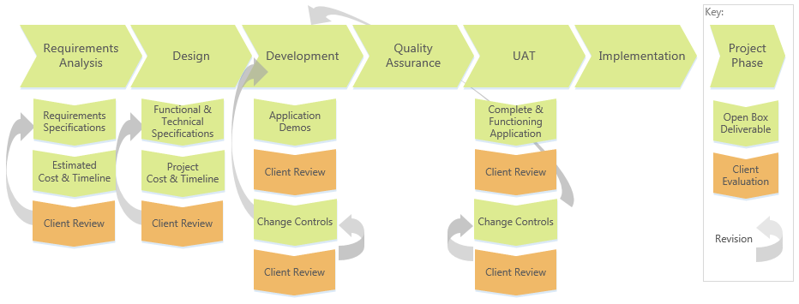
Figure 9: Open Box Project & Evaluation Process
- Requirements Analysis – Open Box will assess the application requirements through consultation with Client Name.
  - All requirements which the application must address will be documented by Open Box in a User Requirements Specification which will be reviewed and signed off by Client Name.
  - Updated costs and timeline estimates will be provided on completion of the requirements analysis.
- Design – Open Box will document the application design in the Functional [and Technical] Specifications which are reviewed and signed off by Client Name.
  - The project cost and timeline will be finalised on approval of the application design.
- Development – Open Box will develop and test the application and will periodically demonstrate project progress to Client Name.
- UAT – Client Name will be responsible for conducting user acceptance testing (UAT).
- Change Controls - Any changes to the approved design will be managed through a change control process.
  - Change requests may arise from Client Name feedback during application demonstrations or during UAT.
  - Each change will be documented by Open Box in a Change Control document which is reviewed by Client Name. Client Name may approve or reject a change control, or defer the change for a subsequent application release.
  - Change controls will incur additional project cost and/or affect project timelines.

Project Team
All work will be completed in-house.
The project team is anticipated to be comprised as follows:
Role | Seniority | Duration (hours)
Table 1: Proposed Project Team
Individual project team members may be substituted, at the discretion of Open Box, for others of similar skills and experience.
The availability of specific individuals is subject to project timelines.

Next Steps
The proposed next steps are:
- Client Name to approve the proposal.
- Client Name to sign the Open Box Master Services Agreement.
- Client Name to provide the requested prerequisites.
- Information / access client must provide.
- Information Open Box must provide. E.g.:
  - Open Box to make recommendations on a content management system as well as hosting environment.
  - Open Box to provide design samples for review.
- Demos to Client of similar systems.
- Open Box to complete requirements analysis and provide an updated cost estimate.
If there are any queries on the content in this proposal, please do not hesitate to contact [Mark Kalkwarf on mkalkwarf@openboxsoftware.com].

Acceptance
[This proposal is concluded in terms of the Master Service Agreement for Consulting Services between the parties (dated [xxxx]) (“MSA"). The services recorded in this proposal will be governed by the terms of this proposal as read together with the MSA.]
The parties hereto, each acting under due and proper authority, have executed this Agreement as of the day, month and year first written below.

For and on behalf of Open Box Software For and on behalf of Client Name

Signature: _____________________ Signature: _____________________
Name: Stephen Thorne Name: [Client Contact Name]
Position: Director, UK Position: [Position]

Date: _____________________ Date: _____________________

Addendum / Appendices

